Introduction to Tosca

- Scriptless, Ai Based, No code automation tool
- Continuous testing platform delivers fast feedback for agile and devops
- Allows us to design functional, automated, end-to-end software tests
- Provides real-time risk assessment with business focus
- Provides test data at any time
- Simulate behaviour of dependent system

Features of Tosca
- Risk based
- Test management
- Manual Testing
- Analytics
- Exploratory testing
- Service virtualization
- Load testing
- Test data management
- API Testing
- BI & Big data
- CI
- Impact analysis

Tosca Components
- Tosca Commander = It enables easy creation, management, execution & analysis of testcases
- Tosca Executor = It executes testcases on the test object
- Tosca Xscan = It scans application and saves technical information of all elements in modules
- Test Repository = It is used to manage the test data needed for test execution

Tosca Vs. Selenium
Tosca | Selenium
Licensed and paid tool | Open source and free tool
Codeless | Code based
Supports all types of application web, desktop, mobile | Supports only web
Dedicated support team for users | Community support
Inbuilt reporting and object repo  Model based | No in-built reporting and repo  Script based
Supports API and load testing | Doesn’t support API testing

New Features released in Tosca 16.0
- Mobile Agent: Seamless connectivity for android and iOS =
- Allows to connect any mobile device local, remote, cloud based

- Enhanced test automation for oracle
- Oracle application is highly customized and integrated in constellation of other system that are under constant change, testing end-to-end is imp.
- Using tosca ID mapper and support for ARIA

- Tosca ID Mapper
- Using ID Mapper, lowers test customization and increase stability
- Select SUT, uniquely identify your control and save default IDs in library
- Library with prebuilt IDs

- Support for ARIA Framework
- ARIA (accessible rich internet application) framework
- Makes web content and applications more accessible to users with disabilities
- Supports browsers, js toolkit, screen readers, Microsoft 365, SAP, Oracle etc

- Dark Theme for UX
- Cloud Licensing reporting
- Tosca admins can now view tosca license cloud consumption over time and access reports without Tricentis support, also alerted to users with no available Tosca commander licenses

- TC Pre-execution approval
- Pre-execution approval is an automated process to request and grant approval for testcases
- Allows us to validate our testcases before they are run and protects validated tc for unauthorized modifications
- Approval process is only for testcases and doesn’t includes other objects like testcase template, business tc, modules and Execution list
- TC Work State lets users know how far TC is: Planned, IN_Work, Complete
- Use pre-execution approval, only tosca can change state:
- Every new Tc that’s in progress = PLANNED
- User request approval for tc, tosca changes tc in IN_Work
- Approval: Completed
- Rejected tc go back to PLANNED

- Other enhancement
- File service
- Support latest SAP Innovations
- Tosca qTest integration
- DEX enhancement
- PDF = 1:1 compare module
- Mainframe rescan = Host Engine 3.0 module
- Support java 17
- Support windows 11

Tosca commander overview
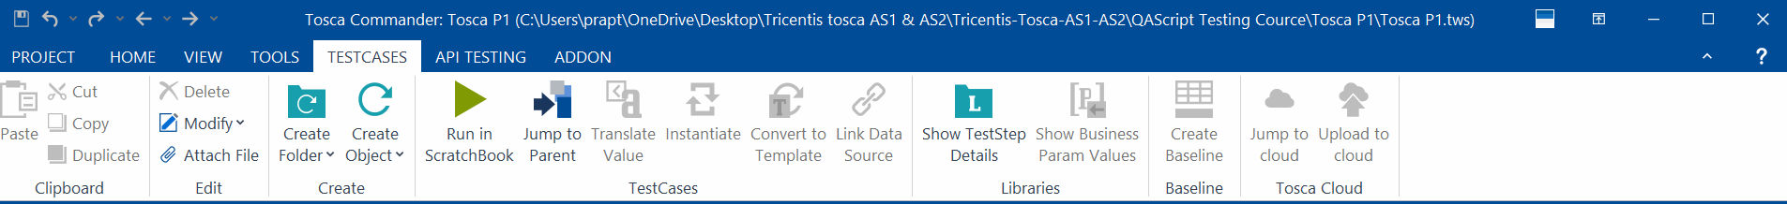
- Tools to automation
- Different sections

Identification Methods
- Identify by properties
- Identify by Anchor
- Identify by Parent
- Identify by Image
- Identify by Index

Rescan, Merge Module, Control Group
Perform File Operation
- Tbox image compare
- Tbox File Existence
- Tbox File Compare
- Tbox Copy file
- Tbox Delete File
- Tbox read/ create File
- Tbox Move/ Rename file

Folder Operation
- Tbox Create Folder
- Path
- Overwrite

- Tbox Copy Folder
- Source path
- Target path
- Overwrite

- Tbox Delete Folder
- Path
- Recursive = by default tosca only delete empty folder, set true to delete folder with content

- Tbox Folder Existence
- Path

Buffer Operation
- Tbox Set Buffer
- Create buffer with value
- Verify value of existing buffer

- Tbox Name to Buffer
- Buffer name of tc

- Tbox Partial Buffer
- Buffer paths of value
- Verify parts of buffered value
- Used when dynamic values are present and to be stored
- Buffer = name
- Value
- Start
- End
- Last = mostly used

- Tbox Delete Buffer
- Remove individual or existing buffer

Process operations
Tbox Start Program
- Path = application.exe / task manager
- Directory = working directory for program
- Arguments = select
- Argument -> argument =
- WaitforExit = wait until application has been exited, set True
- WaitforExit -> StandardOutputFile = to create log, give path and name of log file
- WaitforExit -> TimeoutForExit = max. time in seconds tosca should wait before exiting application
- WaitforExit -> ExitCode = verify application’s exit code
- Run as = define domain or local user credentials tosca should use to open application
- Run as -> Username
- Run as -> Password

- To start TCShell.exe, which is located at %COMMANDER_HOME%.

Close Program
- Use Tbox Start Program
- Path = taskkill (windows operations)
- Argument = select
- Argument = task manager / .exe
- Argument = /im
- Argument = /f

Expression Evaluation
- Allows you to perform comparisons
- Result is True or False
- Verify Maths Equations
- Compare dynamic expression

Tbox Take ScreenShot
- Takes Screen shot of currently active screen
- Environment = select drop-down menu
- Directory = path to store ss
- Filename = name of file

- Setting > Tbox > Logging > ScreenShot > make screenshot on failed test steps = Detection Failure /verification failure / off

Window Operation
- Tbox Take ScreenShot
- Tbox Clipboard
- Allows you to copy text to clipboard
- Use it to verify text that’s in clipboard or to save that text to buffer
- Value = value that you want to copy to clipboard, verify, or buffer

- Tbox Dialog
- Used to perform operation on the popups
- Windows dialog = scan them without scanning them
- Customized dialog = need to scan them first
- Caption = caption of window popup
- Label = first paragraph
- Button

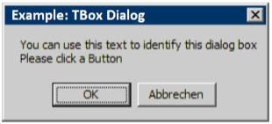
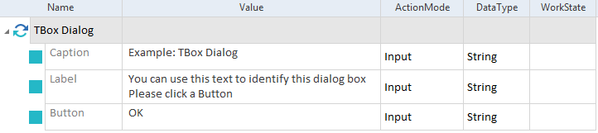

- Tbox Context Menu
- Steers windows applications context menus without need to scan
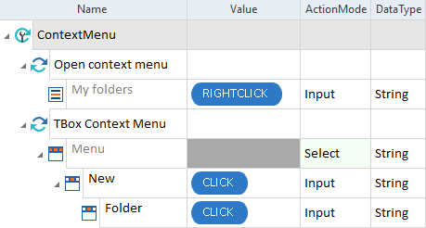
- Tbox Send Keys
- Sends keyboard commands to window
- Uses WinForms Function Send Keys
- Caption =
- Keys = want to send to windows
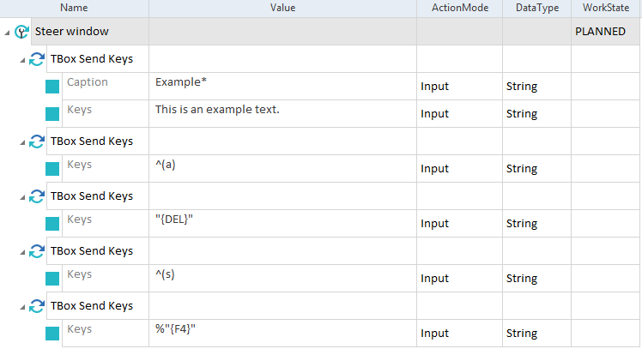
- Special character = {,}, [ and]
- “”
- To escape all special characters:
- Enclose in { } [ ] = {{}B{[}Buffer{]}{}}
- Add double quotation = “” {{}B{[}Buffer{]}{}} ””
- Enclose whole string with “”” {{}B{[}Buffer{]}{}}””” = “{B[Buffer]}”

- Tbox window Operation
- Sends specific commands to window
- Caption
- Operation
- Operation -> height
- Operation -> width
- Window index
Operations
- Bring to Front
- Close
- Maximize
- Minimize
- Move to center
- Normal
- Resize
- Verify windows exists
- Wait on close
- Wait on open

- Tbox Scroll window operations
- Allows you to define scrolling behaviour
- Caption = window application
- Window index
- Vertical
- Horizontal
- MousePolicy = centre(default), none
- DirectionPolicy = no direction policy(default), horizontal first, vertical first
- Delay = ms

- Tbox Save As
- Steers dialog window SaveAs, SaveAs dialog box has to open
- Caption
- FileNameLabel
- FilePath
- Button
- ConfirmationPopupCaption
- ConfirmationPopupButton
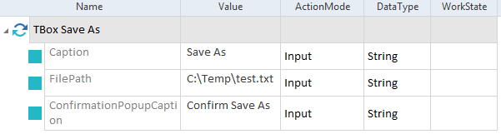

Numeric Operation
- Allows you to convert decimal of specific format into another format or culture.
- Culture name = as de or en
- MathFormat
- ToscaFromat
- TargetFormat
- Input Value = select
- Value = value to convert
- Decimal format = format the input value
- Converted value = select
- Value = desired output value
- Decimal format
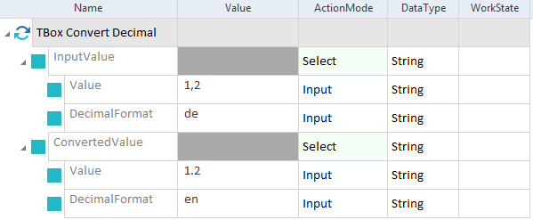

Perform Calculations
- Use expression CALC or MATH
- CALC = if you have Microsoft excel 2010 or later installed
- MATH = if you do not have Microsoft excel installed

- Use CALC
- Syntax: {CALC[<Operand1> <Operantor><Operand 2> …… < Operator><Operandn>]}
- Enter excel formula into []
- By default CALC uses English expression. We can change language
- Using TCP named ExcelLanguage and value local
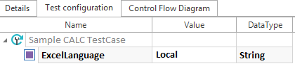
- Use quotes to escape special character in string
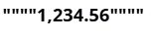
- {CALC[2*2+5]}, {CALC[2*(2+5)]}
- {CALC[1000+""""1,000.50""""]} = 2000.50
- {CALC[1000+""""{B[Example]}""""]} = uses buffer
- We can combine CALC with
- Buffer
- Random values
- Time and date expression

- MATH Function
- Abs
- Ceiling
- Floor
- Max
- Min
- Pow
- Round
- Sign
- Sqrt
- Truncate

Resource Handling
- Tbox Delete Resource
- Allows you to delete resource
- Resource = name of resource to be delete
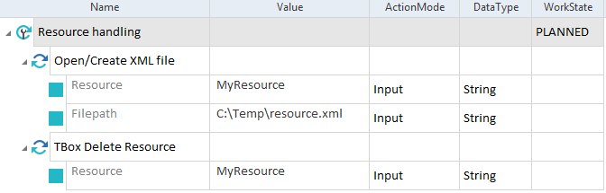

Selenium
Supported formats
- NUnit or Junit 4 Tc
- Junit 5 Tc
- DLL and JAR files which contains Selenium 1 (remote control)
- Selenium 2 (web Driver tc)
Supported test frameworks
- Selenium java 3.9.1 to execute selenium Junit 4 tests
- Selenium -jupiter 3.4.0 to execute selenium Junit 5 tests
- NUnit 2.6.4 to execute Selenium C# tests
Prerequisites
- To run selenium tests, you need to copy the file .dll from %TBOX_HOME% to directory that contains selenium testcases.

- Start Selenium Server
- Defines connection properties for selenium 1
- Selenium server path = JAR file
- Selenium Port = port for selenium server, tosca open it from 4444 action mode select
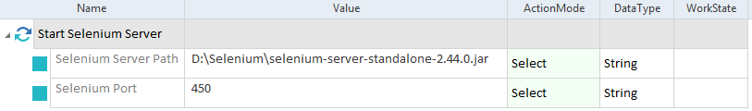

- Run Selenium Server
- This module starts selenium scripts, result in Loginfo column in ExecutionEntry
- Path = to Dll or JAR file, contains TestMethods that we want to execute
- TestClass = Class from DLL or JAR file where TestMethods are located
- TestMethod
- Report Directory = store result
- To run all tests within DLL or JAR , leave TestClass and TestMethod Empty
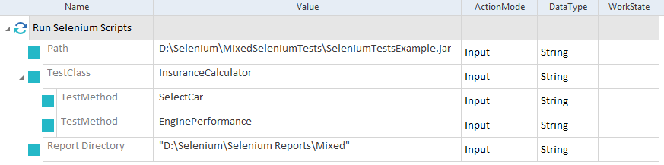

Timing
- Tbox start timer and Tbox Stop timer
- To measure execution time
- Set multiple timers with different name
- ID = name of timer
- Maximal Duration = compare actual timer result with expected result
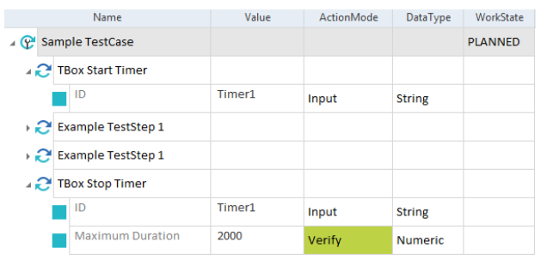

- Tbox Wait
- Delays between tc or teststeps.
- Duration = time in ms

